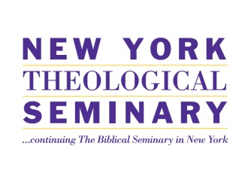
New York Theological Seminary’s “Count the Cost Initiative” is a three-year project designed to research student indebtedness and develop long-term economic strategies that better prepare future ministers and NYTS partner churches.

The project will:
A. Research the debt and employment of all NYTS students and alumni (2014 and 2015);
B. Establish a financial training/coaching/business planning initiative for NYTS students;
• personal-financial training
• submission of a personal “business plan”
• supplying personal-finance coaching for new students
C. Research the financial and organizational characteristics and health of constituent churches; and
D. Create a pilot technical assistance program for one or two constituency churches that may lead to replicable and sustainable projects after the grant term ends.

NYTS has worked diligently to engage the faculty, staff, students, alumni, trustees and constituent churches in the “Count the Cost Initiative.” In addition to scheduled monthly team meetings, presentations have been made at the Spring Student Retreat, Borough Alumni Gatherings and special events.

Working with the research team from Auburn Theological Seminary, the Count the Cost Initiative team has developed the assessment instruments for the 2014 NYTS graduating students in the Master’s Degree Programs. The graduate survey will capture how students finance their theological education, consumer debts, current financial life, ecclesiastical status, occupation and goals. Meetings were held with the graduating class and with the entire student body to introduce the project and to solicit student support. Release of the graduate survey will coincide with the Office of Student Affairs’ completion of exiting interviews at the end of the month of April. To help to secure 100% participation in a timely manner, the Count the Cost Initiative will provide graduates who complete the survey within the designated time periods with the opportunity to qualify to win an iPad and/or a Kindle.

Training for the first team of researchers for the assessment of the organizational characteristics and health of constituent churches has been completed. More than half of the constituent churches have been identified and quantitative analysis will be completed by April 30, 2014. In addition to assessing the financial health of the churches, each constituent church will have the opportunity to participate in a funding and fundraising roundtable with foundations currently engaged in funding faith-based and religious initiatives.

Cynthia Gardner-Brim, Project Director
New York Theological Seminary
475 Riverside Drive, Suite 500
New York, NY 10115
(212) 870-1244
gardnerbrim@nyts.edu

